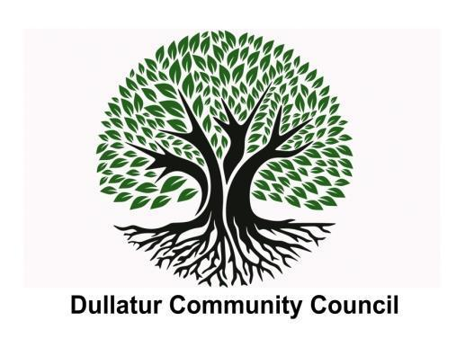

**Meeting Minutes – 7th February 2024**

**Location – Dullatur Village Hall**

**Attendees:**

|  |  |
| --- | --- |
| **Community Councillors** | **Supporting Groups / Members of Public** |
| Gerard Burns (GB)  Alan Davidson (AD)  Andre de Almeida (AdA)  Lorraine Harkins (LH) - Apologies  Clare Ross (CR) - Apologies  Ewan McMillan (EMcM) - Apologies  Vivien Mitchell (VM) – Apologies  John Wright (JW) – Absent | Alan Masterton (AM) – North Lanarkshire Council  Martin Rae – Police Scotland – Apologies |

**Agenda:**

|  |  |
| --- | --- |
| **Item** | **Discussion** |
| **(1) Welcome**  **(2) Approval of Minutes** | GB welcomed everyone to the meeting as acting Chair and AdA volunteered to take the minutes for the meeting, in EMcM’s absence.  Any actions outstanding have been carried over.  Minutes from 13th December were noted and approved. These will now be posted on the Dullatur Community Council website. |
| **(3) Treasurers Report** | AD provided the Treasurers Report. In summary, Treasurers account – £1,298.63  Maintenance account – £1,312.49  Administration grant received from North Lanarkshire Council (NLC) for £450 and paid into Treasurer’s account in December.  In addition, AD applied for a community grant to fund insulation of external bathroom door and infra red heater with detector – confirmation of application received and waiting for response from NLC, application is due to be considered on 26th February. |
| **(4) Update from North Lanarkshire Council** | Discussion by committee with AM on recent weather events and impact on local community including the risk of damage caused by trees, including the one that fell and almost hit the Dullatur Village Hall.  Tree Protection Order (TPO) covers Dullatur Village, and any proposed changes need to be approved by NLC via a formal application. GB to contact Rosalynn Toal (NLC) and include AM on the communication, as the process online to raise these is unwieldy and not user friendly at present. |
| **(5) Planning Applications** | Three items received from the Planning Department have been posted on the Dullatur Community Council website.   1. Local Outcome Improvement Plan 2. Dullatur Appraisal and Management Plan 3. Town Centre Action Plan |
| **(6) Update from Police Scotland** | MR was unable to attend due to an operational matter. |
| **(7) Hall Bookings/Use of Hall** | Pilates class. Committee has approved for class to be extended as requested from 2 to 3 nights per week (Monday, Tuesday and Thursday) on condition that if another group requests use of the hall, we will have to revise the bookings in the medium term as we want to continue to encourage the use of the hall for various activities.  Also agreed that any non residents requesting use of the hall (if available) on condition that proposed activity/use of hall will not cause disruption to local area, pending DCC approval. |
| **(8) Community Events** | Discussed events for 2024 such as Easter Egg Hunt, Summer BBQ, Outdoor Cinema, Christmas Market.  Dates need to be agreed by the next DCC meeting to allow for planning.  Suggestion is for the 1st event during Easter to be run in conjunction with DLTC to help promote membership of sports club and use of facilities. AdA to follow up with DLTC. |
| **(9) AOB** | GB agreed to laminate notice to go on the notice board informing local residents that all DCC minutes can be accessed via the website: <https://www.dullatur.org/community-council>  Next DCC meeting planned for Wednesday 13th March at 7pm at the Dullatur Village Hall. |