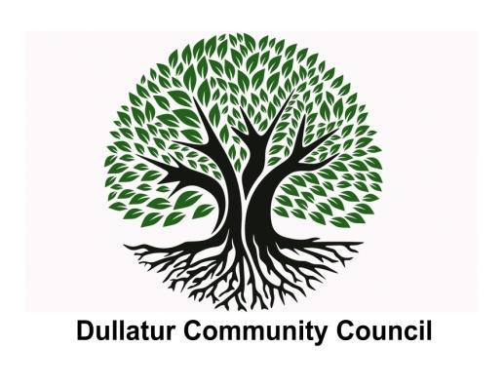

**Dullatur Community Council**

**Meeting Minutes – 11 May 2023; Dullatur Village Hall**

**Attendees:**

| **Community Councillors** | **Supporting Groups / Members of Public** |
| --- | --- |
| Clare Ross (Apologies)  Alan Davidson  Andre de Almeida  Gerard Burns  Margaret Kennedy (Absent)  Vivien Mitchell (Apologies)  John Wright (Absent) | Alan Masterton (Apologies) |

**Agenda:**

| **Item** | **Discussion** |
| --- | --- |
| **Welcome** | CR was absent so it was agreed that AD would chair the meeting. |
| **Finance Report** | Balance in maintenance account as at 24 April was £1,585.81 in Maintenance Account and £863.21 in Treasurer’s Account. We raised £900 (after costs) from the Social Event..  It was noted that our Insurance arrangements had renewed on a similar basis to last year with only a small increase in premium. |
| **Village Hall** | Now that the internal works have been completed the Committee discussed proposals to deck the space outside of the hall in order that the doors can be used to access the outside space. The Committee agreed a spend of up to £2,000 with respect to this with CR/GB to explore options for completing this work. It was noted that DLTC had kindly agreed to make a donation of £500 towards the decking. |
| **Planning** | GB gave an update on recent discussions he had held with NLC around TPOs. NLC guidance is confusing and restrictive with in most cases NLC requiring permission before work is carried out. |
| **Community Matters** | Following matters were discussed:   * DLTC/DCC Social - following the success of the last fundraiser it was agreed to explore with DLTC the opportunity for holding a joint social. |
| **AOB** | Chair thanked all for attending and closed the meeting. |