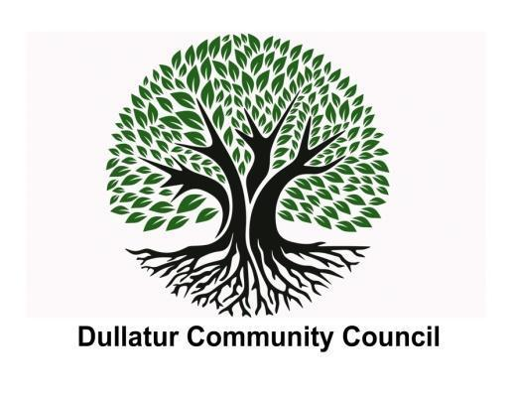

**Meeting Minutes – 13th March 2024**

**Location – Dullatur Village Hall**

**Attendees:**

|  |  |
| --- | --- |
| **Community Councillors** | **Supporting Groups / Members of Public** |
| Gerard Burns (GB) – Apologies  Alan Davidson (AD) – Apologies  Andre de Almeida (AdA)  Lorraine Harkins (LH) – Apologies  Clare Ross (CR) – Apologies  Ewan McMillan (EMcM)  Vivien Mitchell (VM) – Apologies  John Wright (JW) – Absent | Alan Masterton (AM) – North Lanarkshire Council  Martin Rae – Police Scotland – Apologies |

**Agenda:**

|  |  |
| --- | --- |
| **Item** | **Discussion** |
| **(1) Welcome**  **(2) Approval of Minutes** | EMcM welcomed everyone and it was agreed that he would Chair the meeting.  Any actions outstanding have been carried over.  Minutes from 7th February following two small amendments were noted and approved. These will now be posted on the Dullatur Community Council website. |
| **(3) Treasurer’s Report** | AD provided the Treasurer’s Report.   1. Community Grant – we were successful in getting an award of £221 towards new heaters/door insulation (we claimed for £1000). You can claim up to £1000 in any one year, so we are able to submit further claims. 2. Updated maintenance account balance as of 23rd February is £2382.14 (this doesn’t include the grant above). 3. No change in treasurers account balance from last month (£1301.76).   AD agreed to take an action to follow up with electrician to firm up a quote for the heaters and bring back to the next meeting now that we know what grant we have. |
| **(4) Update from North Lanarkshire Council** | There was nothing in particular raised by AM, but we did discuss the ongoing communication between DCC and NLC on tree management and specifically Tree Preservation Order (TPO). It does appear that action is not forthcoming despite effort from GB. Agreed that we should all understand what communication has been made/received and discuss at our next meeting. Further, once agreed, this would be posted on the DCC website.  VM enquired about the ongoing state of the speed bumps. Rather than temporary repairs, more permanent mono-blocking is required. AM agreed to raise with the relevant department within NLC. |
| **(5) Planning Applications** | No new information from NLC planning department since the three items below (posted on DCC website).   1. Local Outcome Improvement Plan 2. Dullatur Appraisal and Management Plan 3. Town Centre Action Plan |
| **(6) Update from Police Scotland** | MR was unable to attend due to his shift pattern. He did provide a report and in summary, in the February/March period there were 14 incidents reported in the Dullatur area with 0 crimes recorded. Full report sent separately, and we can discuss whether this should also be posted on the DCC website. |
| **(7) Hall Bookings/Use of Hall** | Agreed that this item would be discussed at our next meeting, covering hall use and pricing. |
| **(8) Community Events** | The first event of 2024 is likely to take place on Saturday 20th April. A Spring event jointly arranged with DLTC. Date to be confirmed (DLTC meeting on Saturday 16th March) and thereafter format of the day to be agreed.  Outline timetable would be Spring, Summer, Autumn and Christmas events. Some great ideas previously discussed and could also do another social event that was well received last year.    Again, perhaps worth publishing this outline timetable once agreed to reinforce that there is a plan, building on the successful events from last year. To be discussed at our next meeting. |
| **(9) AOB** | All agreed that we need to keep the noticeboard populated with engaging and attractive materials. Minutes need not be posted as they are on the website, leaving space for event posters and indeed DCC contact details.  LH previously mentioned distributing a flyer to aid with communication. Worthy of further discussion at our next meeting.  GB agreed to laminate notice to go on the notice board informing local residents that all DCC minutes can be accessed via the website: <https://www.dullatur.org/community-council>  Next DCC meeting planned for Wednesday 10th April at 7pm at Dullatur Village Hall. |